JobLogServ.java is a servlet. Data is extracted and return json formatted string.

When user request data for parameter among the three RunID,Entity,Date , these parameters are send as queryparam to that servlet.

For the both Job-log and Message-log at first connection is created with Mysql. Then a query is executed to that database including these query-params, Then a resultset is generated. According to that resultset, a json string is generated and returned when retrivejoblog or retrivemsglog method is invoked.

But For the Error-Log at first connection is created with the Mysql for getting the redshift credentials like class name, url, userid, password. Uning EncryptionUtill class this credentials are decrypted. Then using that credentials, connection is created with RedShift and error table data is populated as resultset. Then this resultset is formatted as Json string and returned when retriveerrorlog method is invoked.

Index.html : It is the UI of this Log viewer. Here User can provide runid or entity or Date to search data from log. Atleast one parameter is mandatory to get the result from server. These fields are validated using jquery in client side. Here we are using one DataTable plugin in jquery. According to these parameters Ajax is called from Datatable and service methods are called and the result is populated as a datatable.

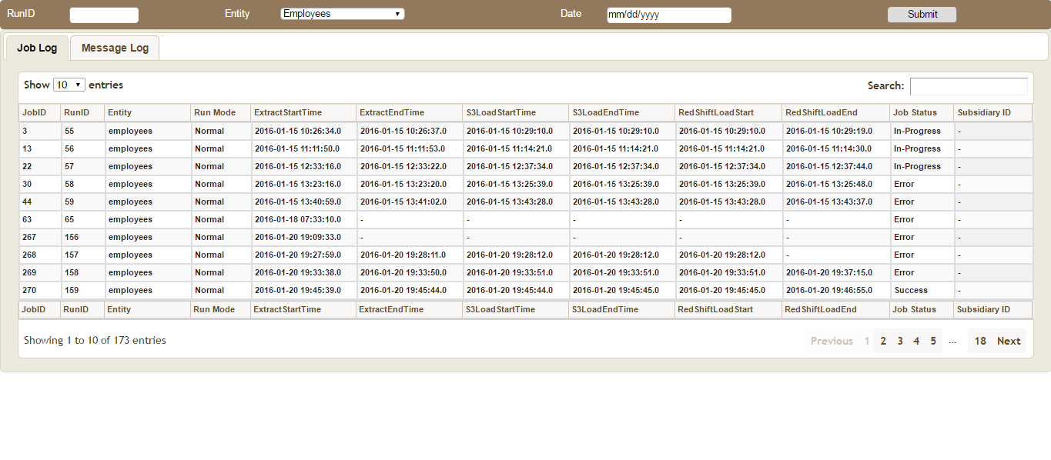
JobLog Example

Style.css: It is used for styling the UI of LogViewer.
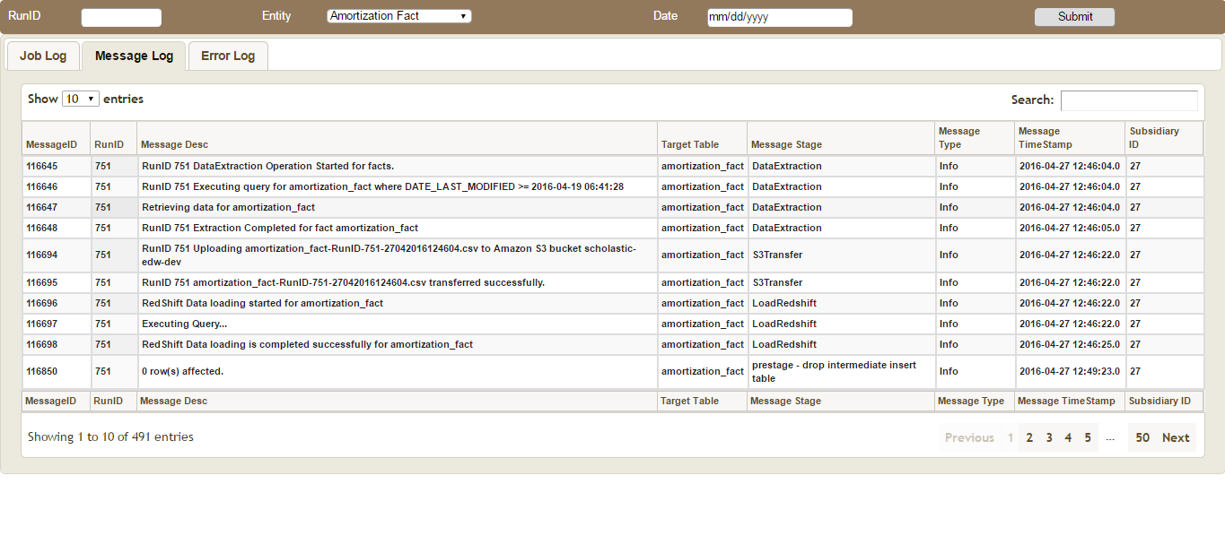
Message-Log Example

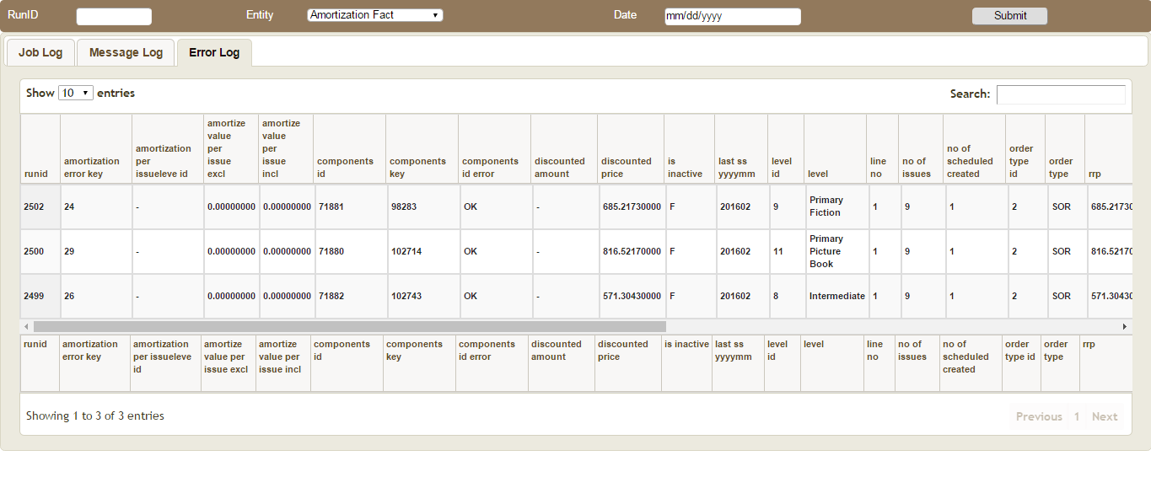
Error-Log Example

